**Webex Teams Hackathon 2018**

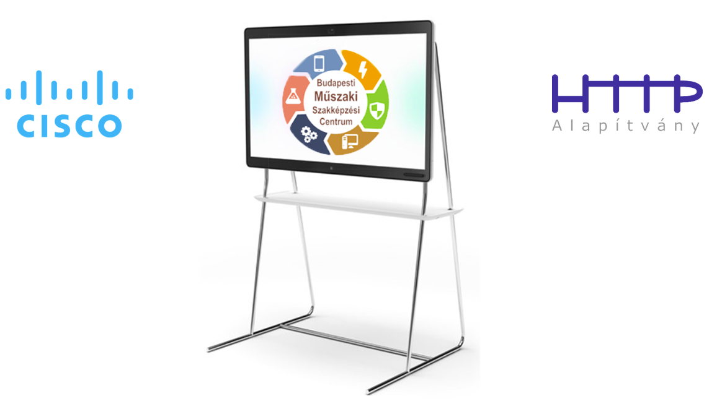

**Lab5 – Creating Webex Teams Bot**

# Objectives

In this lab, you will complete the following objectives:

* Create a Webex Teams bot
* Add the bot to a 1-to-1 Webex Teams space and send a message
* Add the bot to a Webex Teams group space and send a message with the bot mentioned in it

# Background / Scenario

Bots are similar to regular Webex Teams users. They can participate in 1-to-1 and group spaces and users can message them directly or add them to a group space. A bot can only access messages sent to it directly. In group spaces, bots must be @mentioned to access the message. In 1-to-1 spaces, a bot has access to all messages from the user.

Webhook is used to send notifications about actions where a bot is affected (e.g. a message was sent where bot was mentioned). When we create a webhook we have to define an URL of a POST type REST API endpoint. When a bot action happens Webex Teams environment will send a POST request to this endpoint with the details of the action.

If we would like to create a Webex Teams bot application we have to create a bot, create a webhook and develop a back end system at least with a POST type endpoint for the webhook. Backend system will responsible for processing data received by webhook request and it also can be used to send Webex Teams messages in the name of the bot.

In this lab we will create a Webex Teams bot. Webhook creation procedure will be described in the next lab.

When completed, you will have a new Webex Teams bot which can be added to a Webex Teams space.

# Required Resources

* Webex Teams client

**Step 1: Create Project for Deployment**

In this step, you will create your first bot.

1. In your web browser navigate to <https://developer.webex.com> page.
2. Click to “Login” link on the top right part of the page and login with your Webex Teams username and password.
3. Click to your profile icon on the top right part of the page. Select “My Webex Teams App” link.

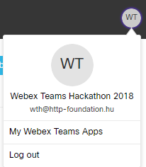

1. Click to “Create a New App”.
2. Click to “Create a Bot” button

**Note:** For detailed description of Webex Teams bots you can navigate to the documentation page using “Learn more” link.

1. On the next page choose a name for your bot. Use wth2018-<nnnn> as bot name where <nnnn> is a randomly selected four-digit number (e.g. wth2018-0654).
2. Choose username for your bot. Use wth2018-<nnnn>@webex.bot as bot username where wth2018-<nnnn> is the name of the bot you chose during in the previous step.

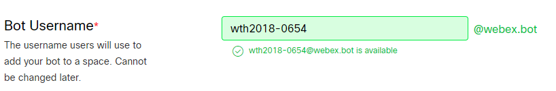

**Note:** Bot username must be identical for the scope of the whole Webex Teams environment.

1. A special badge is added to a bot's avatar in the Webex Teams clients so users know they're interacting with a bot instead of a human. Select a badge icon for your bot. You can choose from the three predefined icons or you can upload your own image too.

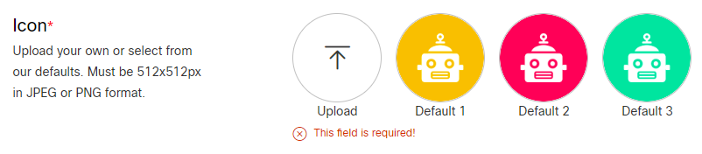

1. Add the following description: “My first Webex Teams bot”.
2. Click to “Add Bot” button.
3. After the bot successfully created you can check all the details of your bot.

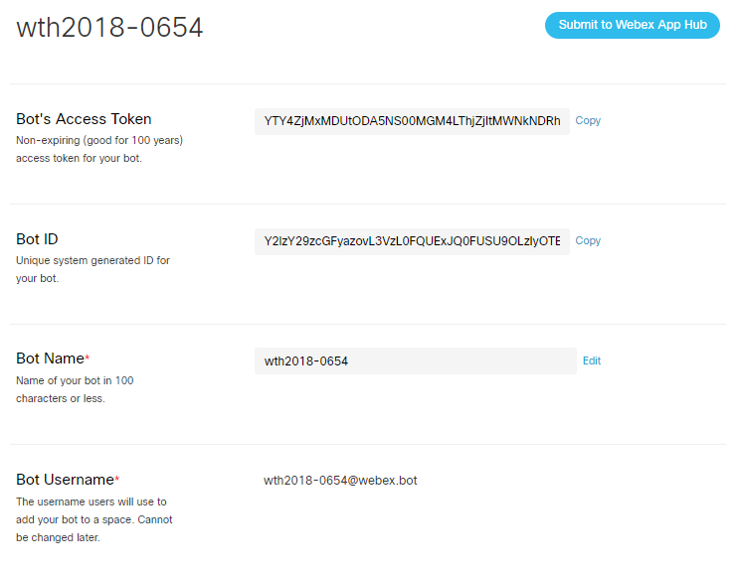

Congratulation! You have created your first Webex Teams bot! ☺

1. Copy the access token to the clipboard and save it to somewhere for further using.

**Note:** Next time when you navigate back to your bot’s page you will not see the token again. If you loose the access token you must regenerate it. By regenerating the token you will revoke your current token.

**Step 2: Add your bot to a 1-1 Webex Teams space**

1. Open your Webex Teams client on your PC.
2. In the search field type the username of your bot.

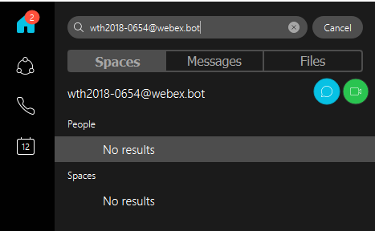

1. Click to the chat icon. A new 1-to-1 spaces space will be created where your bot has access to all messages from you.
2. Send a “Hello” message to your bot. The message will be delivered but you will not receive any response from your bot.

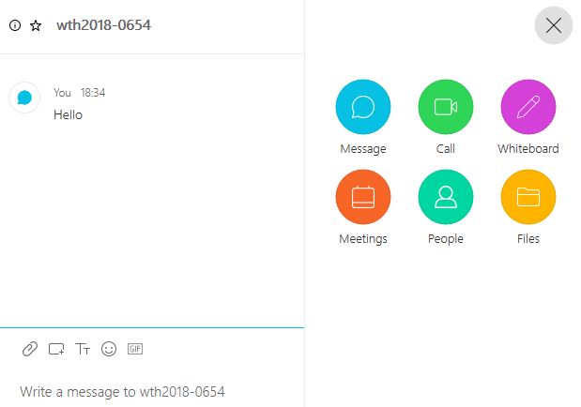

**Step 2: Add your bot to a 1-1 Webex Teams space**

1. Create a new space and named it to “My demo space with my first bot”.
2. Start to type your bot name in “Add people by name or email (optional)” field. Your bot name will appear below the input field. Do not click on it yet!

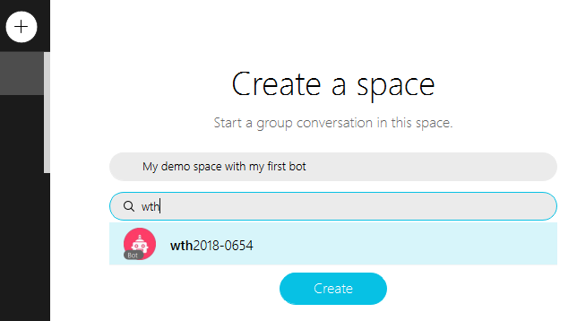

1. Click to “Create” button.
2. Click the toolbar icon on the right top side of the application window.  
   
3. Select People icon from the toolbar then click to Add people icon.

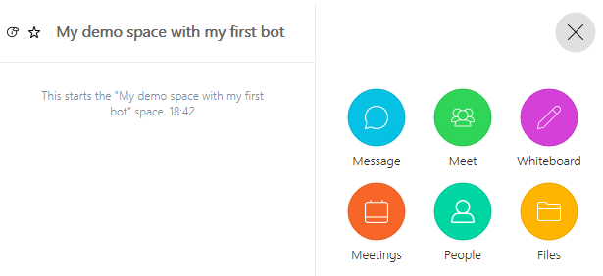

1. In the input box start to type your bot name. When your bot name appears below the input field, click on it. Your bot will be added to the space.
2. Send a hello message with your bot mentioned in it. Type @ character first. Members of the space will appear in the list. You should find your bot name there.

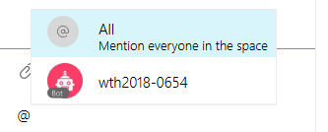

1. Click on your bot name. Continue to type your “hello” message after your bot name.

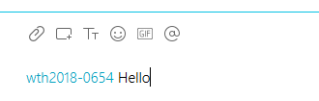

1. Send your message. The message will be delivered to everyone including your but you will not receive any response from your bot.

